TOYS
BOAT………….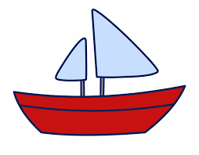………..VARKA

DOLL………….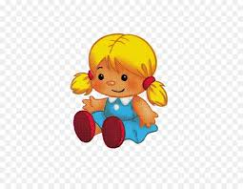 ……….KUKULLA

TRAIN……….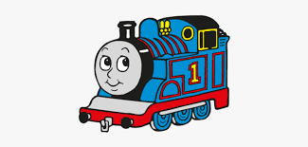…………TRENI

