FLETE PUNE 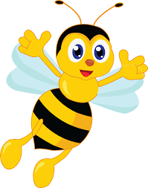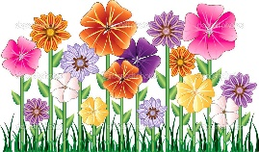
YLLI I POEZISË
Kush merr pjesë ne këtë poezi ?
__________________________________________________

Ku ndodh ngjarja? Çka bisedojne ato? __________________________________________________________________________________________________________________________________________________________________________________________________________________________________________________________________________________________________________________________________________________________________________________________________________

“DJALI DHE BLETA”

Çka e pyeti djali bletën? Si u përgjigj bleta?
___________________________________________________________________________________________________________________________________________________________________________________________________________________________________________________________________________________________________________________________________________________________________________________________ ____________________

Ç ′ mendoni për bletën dhe punën e saj? Cila ështe porosia e kësaj poezie?
______________________________________________________________________________________________________________________________________________________________________________________________________________________________________________________________________________________________________________________________________________________________________________________________________

