Fletë pune në gjuhë shqipe për klasën e II
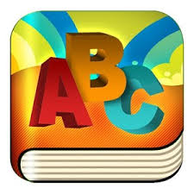
Tema: Tingulli dhe shkronja”

Diktim dhe vetdiktim.
Emri i nxënësit: ________________________________

1. Shkruaj fjalë me shkronjat e mësuara të shtypit :
A ___________________ ,__________________, __________________,
B ___________________, ___________________, ___________________,
Z ________________________ , ________________________, _______________________,

2. Shkruaji shkronjat e mëdha dhe të vogla të mësuara deri tani :
____________________________________________________________________________________________________________________________________________
_____________________________________________________________________________________________________________

____________________________________________________________________________________________________________________________________________
_____________________________________________________________________________________________________________

____________________________________________________________________________________________________________________________________________
_____________________________________________________________________________________________________________

3. Diktim nga ana e arsimtarit me shkronjat e mësuara të shkrimit :
_____________________________________________________________________
_____________________________________________________________________
__________________________________________________________________________________________________________

_____________________________________________________________________
_____________________________________________________________________
_________________________________________________________________________________________________________

_____________________________________________________________________
_____________________________________________________________________
__________________________________________________________________________________________________________

4.Gjej emrin e lules dhe ngjyros :
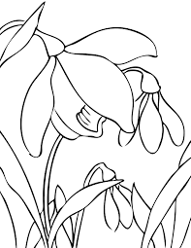 Kontrolloi:_____________
______________________
______________________ Prindi:_____________
__________________________________
Vlerësimi :

